

Foundations of Artificial Intelligence

Tic-Tac-Toe
5x5 board with two consecutive moves each

Team number 2

Janaka Jayalal Mohotti Bandara
Kate Paparsenou
Shuai Yu

AI 801 (Foundations of Artificial Intelligence)
[Spring 2025]
Document Control

Work carried out by:
Full Name | Email Address | Exhaustive list of Tasks
Shuai Yu | sqy5325@psu.edu | Greedy algorithm code, Report write-up, summarization and proofreading, Literature review
Janaka Jayalal Mohotti Bandara | jvm7311@psu.edu | High level design of two move tic tac toe game, Coding Game, Board, TicTacToe, Playgame, utility, minimax search alpha beta pruning and basic heuristic functions.  programmatically play games against different agents and collect the performance result for writeup.
Kate Paparsenou | abp6293@psu.edu | Project management, Monte Carlo heuristic function code, Debugging, Report write-up, Literature review

TABLE OF CONTENTS

1 Introduction 3
2 Problem Statement 4
3 Challenges 5
4 Methodology 7
5 Results and Interpretation 10
6 Discussion of Results 13
7 Your Feedback 15
8 References 15

“Artificial Intelligence is an ecosystem multi-disciplinary concepts, techniques, and tools (Machine learning, NLP, Computer vision, logic-based systems, expert systems, planning and scheduling, multi-agent systems, multi-task learning, game theory, decision support system, etc.). It is obvious that no single project template can cover all AI problems.
This template outlines a typical AI project and should be customized and adapted to the scope of your project, and its expected deliverables.”

Introduction
Tic-Tac-Toe is a two-player, turn-based strategy game typically played on a 3x3 grid. The objective of this game is to align 3 identical marks horizontally, vertically, or diagonally. Due to its simplicity, fully observable state space, and discrete outcomes, Tic-Tac-Toe provides an ideal platform for the development and evaluation of artificial intelligence (AI) algorithms. Its limited number of possible board configurations also allows for the application of exhaustive search methods, while the clear win and loss conditions facilitate straightforward reward assignment, supporting the implementation of various search algorithms. As a result, multiple AI algorithms utilizing different heuristic evaluation strategies and reinforcement learning approaches have been successfully tested within the controlled environment of this game. However, the Tic-Tac-Toe game’s limited state space enables even the most basic AI algorithms to identify an optimal move within a short time. To more effectively compare the applicability and performance of different AI algorithms in finding optimal and efficient moves, a variant of the Tic-Tac-Toe game was developed for this project.

The modified Tic-Tac-Toe variant incorporates two primary changes: (1) the use of a larger 5x5 playing board and (2) the requirement for each player to place two marks per turn. Players alternate turns, marking two pieces on the board. A player wins by aligning 5 identical marks consecutively in a horizontal, vertical, or diagonal direction, as shown in Figure 1. If 24 marks are placed without achieving five in a row, the game results in a draw. The 25th square is disregarded, as no further two-mark move would be possible. This variant introduces an expanded state space because of the larger board and revised rules, creating additional challenges for AI algorithms. With such modifications, the objectives of this project are to: (1) apply different types of AI algorithms to play the modified game, and (2) compare the robustness of these algorithms, specifically evaluating whether certain AI methods would outperform others within reasonable computational timeframes.
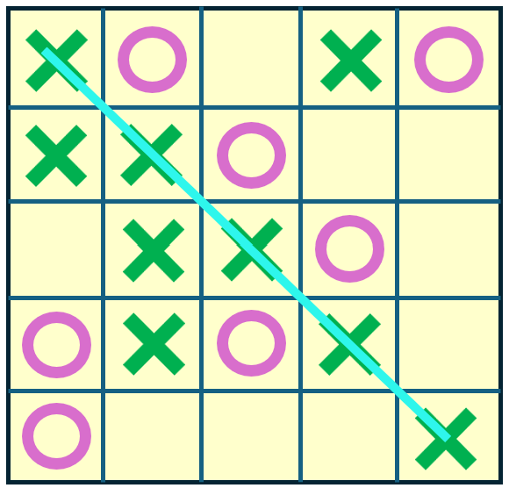
Figure 1 Configuration of the 5x5 Tic-Tac-Toe

Problem Statement
As mentioned above, the objectives of this project are to: (1) apply different types of AI algorithms to play the modified game, and (2) compare the robustness of these algorithms, specifically evaluating whether certain AI methods would outperform others within reasonable computational timeframes.

2.1 Problem Description
i. Initial State (S₀): Game board at start, typically with an empty 5x5 grid.
ii. State Space: The state space consists of all possible board configurations. Since each cell can have 3 states, the maximum theoretical state space is 3^{5x5} = 3²⁵ ≈ 8.4 trillion possible states.
iii. Action Space(s): Actions constitute the set of logical moves of the agents in state space.
iv. Transition Model T (s, a): The transition function determines how the game state changes after a move. The chosen move modifies the board state by placing the player's symbol. If a player achieves a winning condition, the game terminates. If the board fills up with just one cell empty it means that there is no winner and the game ends in a draw.

2.2 Characteristics of the Task Environment
i. Multi-Agent: The Tic-Tac-Toe game is a multi-agent problem where two players compete.
ii. Fully Observable: The agents have access to the complete state of the environment at each point in time.
iii. Deterministic: Every next state of the environment is determined by the current state and the action executed by each agent.
iv. Sequential: Future episodes depend on the actions taken in previous episodes.
v. Static: The environment cannot change while an agent is deliberating. The appearance of the Block Tile happens before the agent’s turn.
vi. Discrete: There is a finite number of distinct states.
vii. Known: The agents know the ‘laws of physics of the environment (eg. what the legal moves are, what the goal state is etc.)

Challenges
When the game board is expanded from 3×3 to 5×5, and each player is required to place two marks at once per turn instead of one, the computational effort required for decision-making increases significantly due to the three explosions below:

(1) State Space Explosion
In a 3×3 Tic-Tac-Toe board, a total of 9 cells can be empty. The theoretical number of possible board states is 3⁹=19683. On the contrary, a total of 25 cells in a 5×5 game board can be empty, which leads to 3²⁵ ≈ 8.4×10¹¹ possible board states. The state space grows exponentially with the number of cells, and moving from 9 cells to 25 cells makes exhaustive search and evaluation orders of magnitude more difficult.

(2) Action Space Expansion (Two Moves per Turn)
In traditional Tic-Tac-Toe, a player selects one move from the available empty cells at each turn. However, each turn requires selecting two distinct empty cells in the 5×5 variant,
If there are n empty cells remaining, the number of possible action pairs is n(n−1)/2. This quadratic growth further increases the possible moves significantly. For example, if there are 20 empty cells on the board, the two moves per turn will evaluate (20×19)/2 =190 possible combinations, compared to only 20 possible single moves in the traditional game.

(3) Search Tree Growth
Because each move requires placing two marks, and exponentially more board states, the search tree grows much wider and deeper. For algorithms like Minimax, the number of nodes that must be evaluated increases rapidly, making full-depth search computationally infeasible without heuristic cutoffs or pruning strategies.
Therefore, the challenge was to implement an efficient decision-making algorithm that handles the larger board size and the higher uncertainty. We will evaluate the appropriate algorithms or heuristic methods to improve computational efficiency and find the optimum moves for the enlarged game board.

3.1 Related Works
To manage the complexity of larger boards (e.g. 4x4, 5x5) in Tic-Tac-Toe games, the relevant research focuses on alternative methodologies to brute-force solutions such as the basic form of Minimax, that can be efficient in terms of computing time and outcome (i.e. win or draw). Authors who analyze zero-sum game strategies provide optimized versions of Minimax, combining the tactical strength of Minimax with more strategic approaches such as Monte Carlo Tree Search and Neural Networks, while also exploring entirely different alternatives, leveraging Reinforcement Learning and other novel approaches.

Focusing on hybrid approaches that combine Minimax with more sophisticated techniques, we learned that they can offer promising solutions to the scalability and efficiency challenges in complex game environments, such as larger boards. Specifically, combining Monte Carlo Tree Search with Minimax can lead to significant improvements because we can leverage the strengths of both algorithms. MCTS is effective in handling large search spaces through simulation-based decision-making, while Minimax provides a tactical approach with deterministic evaluations [2]. Different knowledge-free approaches have been studied that integrate Minimax techniques into MCTS, including its application in the rollout, selection and expansion, and backpropagation phases. Experimental results demonstrate that these hybrid techniques can outperform standalone MCTS or Minimax in specific game scenarios [2]. Although literature covered such hybrid algorithms for Connect-Four, the combination has been an inspiration for our Tic-Tac-Toe, since the two games are quite similar to each other.

Beyond Minimax hybrids, literature provides additional perspective to solving larger board Tic-Tac-Toe problems without relying on the traditional Minimax algorithm, which is slow due to its recursive nature. These approaches showcase the power of other techniques, such as Markov Decision Process (MDP) and reinforcement learning.

The MDP models how an agent processes the current state to determine the probability distribution over possible next states. Tic-Tac-Toe can be formulated in an MDP, where each move represents an action that transitions the game into a new state. At each step, the number of available actions corresponds to the number of unoccupied squares on the board. The agent evaluates the expected rewards of the resulting states for each possible action and selects the action with the highest value [4]. During training, the agent learns the value of states and actions by sampling many moves and observing the resulting rewards. To improve learning efficiency, the value updates for each state are progressively reduced as the number of updates increases. Reinforcement learning (RL), which seeks to maximize cumulative rewards through trial and error, can further enhance this process by enabling the agent to look up and select moves with the highest estimated rewards. RL, as a branch of machine learning, provides a robust approach for tackling more complex Tic-Tac-Toe variants. Literature describes generalized agents that solve larger board versions of Tic-Tac-Toe using reinforcement learning, involving iterative training through self-play and feedback mechanisms organized into four components: Experiment Generator, Performance System, Critic, and Generalizer [3].

However, as the size of the game board increases, computational effort grows rapidly. Classical MDP methods such as Value Iteration and Policy Iteration become impractical because the number of board states expands exponentially. The 5×5 board creates a state space too large to store or update exhaustively. Reinforcement learning addresses this challenge better by learning from sampled gameplay experiences rather than requiring full knowledge of all states. However, as the board grows larger, reinforcement learning also demands significantly more training games and often requires deep learning models to approximate state-action values effectively. Therefore, to address the computational complexity for a 5×5 board with trillions of possible states, adjustments to classical algorithms and the application of new learning algorithms are necessary.

Taking this literature review into consideration, we decided to design and implement hybrid players that combine the strengths of the Minimax algorithm with both basic heuristics and Monte Carlo-based techniques, as well as a Greedy algorithm. Our goal is to balance tactical precision with computational efficiency, particularly when addressing the scalability challenges posed by larger Tic-Tac-Toe boards such as 5×5.

Methodology
We create the rules needed for Tic-Tac-Toe games and study the theory of Minimax Search and Alpha-Beta Pruning, Monte Carlo heuristic cutoff for tic-tac-toe games, and greedy algorithms for game development.

4.1 Rule-based Strategy
In the Tic-Tac-Toe game, the player is required to mark the possible state spaces with any two different symbols. The five rule-based strategy used in Tic-Tac-Toe for players winning the games is given in Table 1. However, some algorithms may only take some of the rules instead of all five rules to improve the computational efficiency.

Table 1 Rules in Tic-Tac-Toe [5]
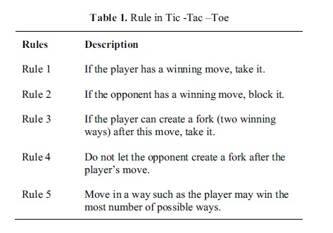

4.2 Minimax search with Alpha Beta Pruning using a basic heuristic cutoff (MMAB-B):
In general, the Minimax algorithm leverages the transition model to explore all potential future game states. The optimal strategy is determined by computing the MINIMAX(s) value for each state in the decision tree. This value represents the utility (for the MAX player) of being in that state, assuming both players make optimal moves until the game concludes. If a state is terminal, its minimax value is simply its utility. In nonterminal states, when it is MAX's turn, the algorithm selects the move leading to the highest minimax value, whereas MIN chooses the move that results in the lowest minimax value.

Given computational limitations, Heuristic Alpha-Beta Tree Search can truncate the Minimax search early and use a heuristic evaluation function to approximate a state's utility, treating nonterminal nodes as if they were terminal. This approach replaces the UTILITY function with EVAL, an estimate of a state's utility. Additionally, the standard terminal test is replaced by a cutoff test, which determines when to halt the search based on the search depth or other relevant properties of the state.

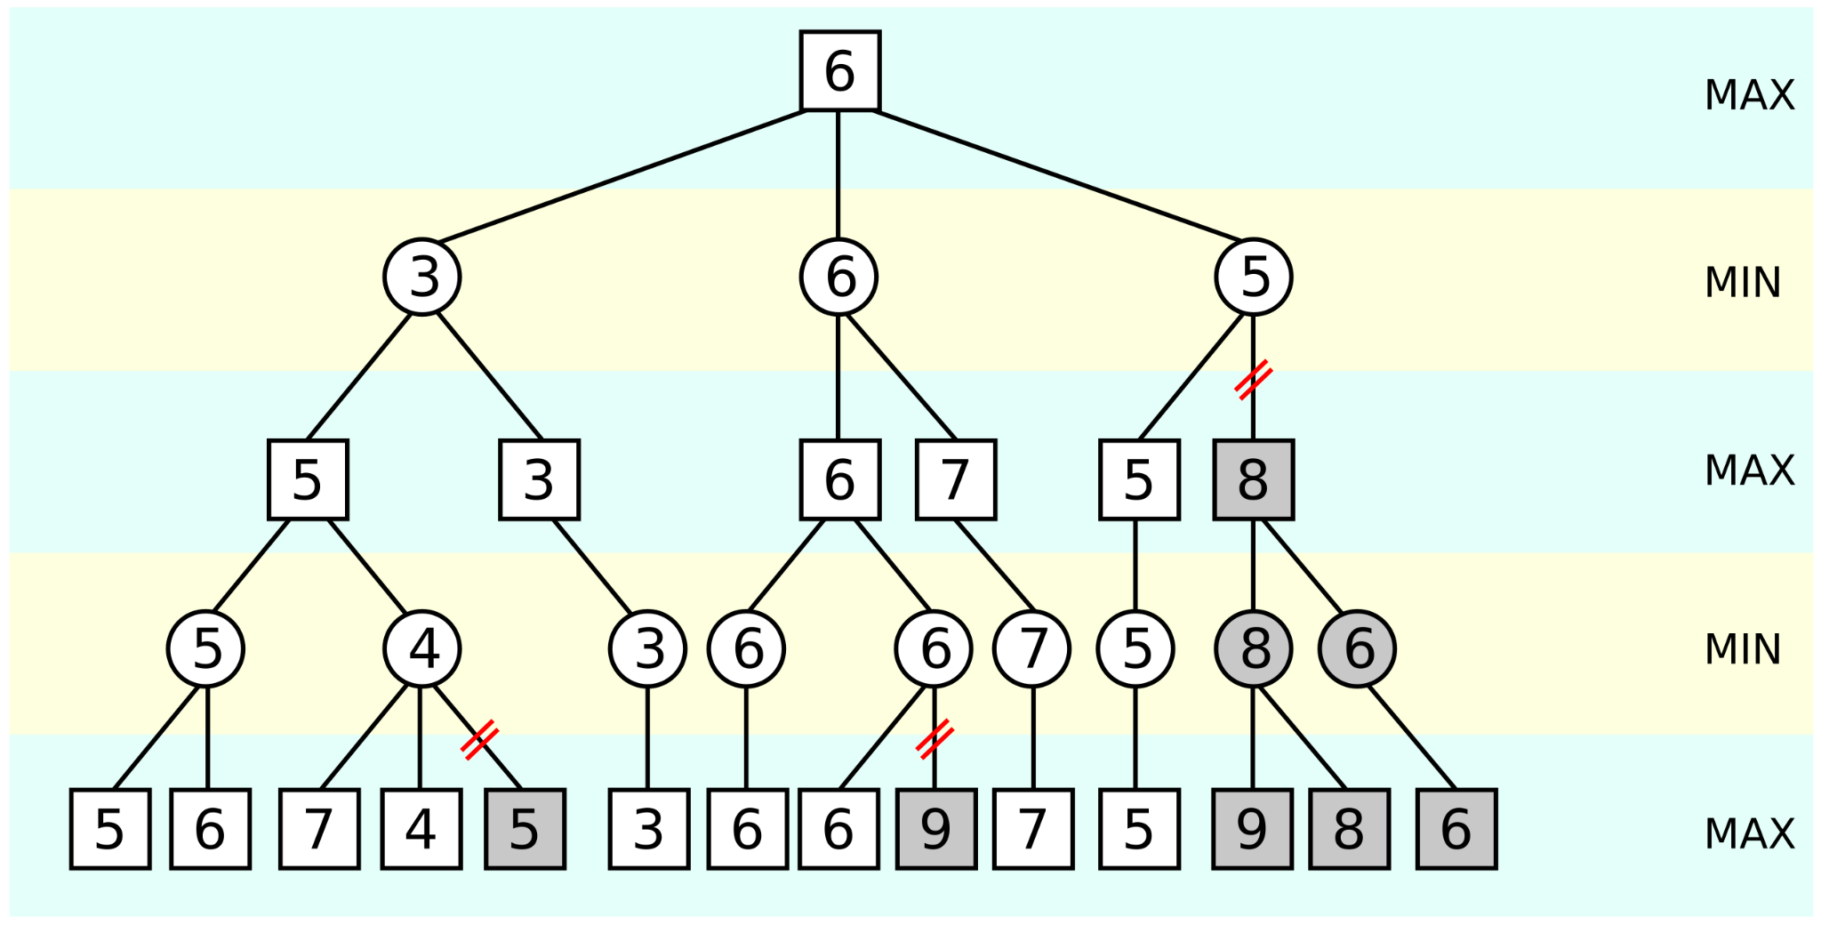
Figure 2 An illustration of alpha–beta pruning [1]

For the purpose of the assignment, a Minimax search algorithm was used with Alpha Beta Pruning twice, adjusted to follow the rules of the game (ie. two moves for every turn, instead of one). The first heuristic to evaluate the utility of a non-terminal state for the given player is a ‘basic’ heuristic that counts the number of empty squares as a proxy of how close we are to the end of the game.

4.3 Minimax search with Alpha Beta Pruning using a Monte Carlo heuristic cutoff (MMAB-MC):
The second algorithm uses the same Minimax search with Alpha Beta Pruning, as mentioned above, and performs a heuristic evaluation of the game state using Monte Carlo simulation. The idea is to estimate how good a certain game state is by simulating random plays from that state multiple times.
It works by repeatedly picking two random legal moves, applying them and updating the game state, until a terminal state is reached or there are fewer than two legal moves. Then, it evaluates the final state using a utility function. Finally, it adds up the scores from all simulations and returns the average score, giving an estimate of the state's utility.

4.4 Greedy algorithm
The greedy algorithm is designed to find a solution in the shortest possible time by selecting the option that appears most optimal at each step, without considering the overall or future impact of those decisions. In the tic-tac-toe board game proposed in this project, expanding the board from 3x3 to 5x5 significantly increases the number of possible moves, which reduces computational efficiency when attempting to find the best overall strategy. The greedy algorithm offers an effective approach to reduce computation time by making quick decisions that may lead to a globally optimal solution through locally optimal choices.
A greedy algorithm selects each step based on a specific evaluation criterion, typically aiming to maximize immediate gain or minimize immediate cost. However, it does not backtrack or consider the broader consequences of each decision, which may lead to suboptimal global results. For example, if the goal is to find the path with the minimum total cost through a tree structure, as shown in Figure 3, a greedy algorithm will choose the lowest-cost node at each level. Starting from the top node with a value of 6, it may proceed to a child node with value 1 (the smallest local cost), and then continue through nodes 8 and 8, totaling 23. However, the globally optimal path would be 6-7-1-5, with a total cost of only 19. This example illustrates that greedy algorithms can miss the optimal global solution in complex structures. Nonetheless, they are highly efficient and valuable for comparison when computational speed is critical, especially in larger game board configurations such as 5x5 tic-tac-toe in this project.

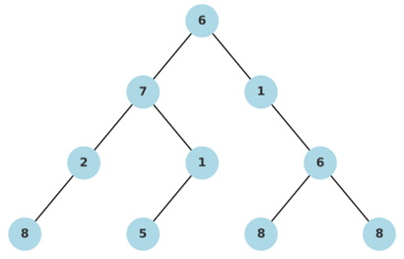
Figure 3 4-Tier Game Tree for greedy illustration

Results and Interpretation
This section presents and analyzes the outcomes of a series of experiments designed to compare the performance of different algorithms in the Tic-Tac-Toe game. The algorithms we included in the evaluation are the following: MMAB-B, MMAB-MC and Greedy, as elaborated above. For the sake of the comparison, we also developed a Random Player, which chooses two random moves during its turn. Their effectiveness was assessed based on win and draw rates, as well as the time complexity.

5.1 Search Algorithm Player vs Random Player
In the first experiment, we compare each of the three strategies (MMAB-B, MMAB-MC, and Greedy) against a Random player.
In terms of win-loss outcome, as expected and as we can see in Table 2, using a search algorithm consistently has a higher chance of winning. In fact, the Random player always loses to the Search Algorithm Player. MMAB-MC has the highest win rate at 60%, significantly better than the Greedy algorithm (40%) and MMAB-B algorithm (20%). Draw percentages range from 40% (MMAB-MC) to 80% (MMAB-B).
In terms of computing time, the Greedy algorithm is the fastest, due to its nature, followed by MMAB-B with 79.036 seconds for five games. MMAB-MC is 1.4 times slower than MMAB-B.
The worst combination of time complexity and winning outcome is for MMAB-B, as it is slower than the Greedy algorithm, yet with worse performance (20% chance of winning vs 40% chance for the Greedy).

Table 2 Comparison of Search Algorithm Player vs Random Player

5.2 Random Player vs Search Algorithm Player
In the second experiment, we compare the same strategies against the Random player, with the difference that the Random player now plays first, as an effort to assess if there is a biased first mover advantage.
In terms of win-loss outcome, as we can see in Table 3, we track exactly the same results for both MMAB-B and MMAB-MC. MMAB-MC has the highest win rate at 60%, significantly better than MMAB-B algorithm (20%). The only difference we notice when we change the order of the players is that the Greedy algorithm doesn’t manage to achieve any win outcome (0% chance of winning), with all the games ending in draw. The Random player, again, always loses to the Search Algorithm Player. Draw percentages now range from 40% (MMAB-MC) to 100% (Greedy).
In terms of computing time, the Greedy algorithm is the fastest, as expected, followed by MMAB-B with 50.007 seconds for five games. MMAB-MC is now reduced to just 1.2 times slower than MMAB-B. As expected, the computing time needed is shorter when the Search Algorithm plays second, because the complexity is reduced due to the fewer scenarios left every time. MMAB-B algorithm’s time is reduced by -37%, while MMAB-MC algorithm’s time is reduced by -47%.
The worst player would now be the Greedy algorithm, because it doesn’t achieve any win outcome. We can also conclude that, indeed, for the Greedy algorithm there is a first mover advantage, while this is not the case for MMAB-B and MMAB-MC, which kept consistent results of both wins and draws, irrespective of the playing order.

Table 3 Comparison of Random Player vs Search Algorithm Player

5.3 MMAB-MC Player vs Greedy Player
In the third experiment, we compare the MMAB-MC Player with different depths (depth=1, 2, 3) vs the Greedy Algorithm Player.
The expectation would be that as the depth increases for the search algorithm, the chance to win also increases, because the algorithm navigates deeper into the future options to take the best possible decision. When the MMAB-MC Player plays first, it always wins. However, when MMAB-MC Player plays second, the outcome is not consistent with the expectation above; while depth at level 1 gives 40% chance to win, depth at level 2 and 3 give no wins for MMAB-MC. This result is believed to be affected by the low number of total games (ie. 5) we allowed the algorithms to play.
Following the first mover advantage insight for the Greedy algorithm in section 5.2, we can notice the same finding here; When the Greedy player plays first, gets chances to win, ranging from 20% to 80%, while when it plays second, it always loses.

Table 4 Comparison of MMAB-MC Player (depth variants) vs Greedy Algorithm Player
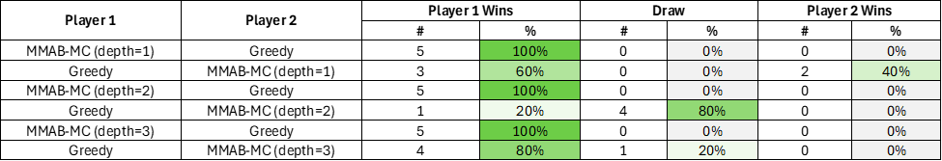

5.4 MMAB-B Player vs Greedy Player
In the fourth experiment, we compare the MMAB-B Player with different depths (depth=1, 2, 3) vs the Greedy Algorithm Player.
The expectation, again, would be that as the depth increases for the search algorithm, the chance to win also increases, because the algorithm navigates deeper into the future options to take the best possible decision. However, we cannot see such a pattern in the experiment results summarized in Table 5. While MMAB-B performs very well at depth level 1, with 100% chance to win, regardless of the playing order, performance is not consistent as the depth level increases. For example, when depth is equal to 3, MMAB-B wins 100% of the games when playing second and wins 0% of the times when playing first. More games would be needed in order to be able to generate insightful findings.

Table 5 Comparison of MMAB-B Player (depth variants) vs Greedy Algorithm Player
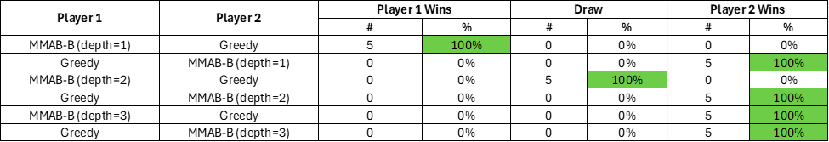

Discussion of Results

6.1 Conclusions
This project implemented several AI algorithms, including Minimax search with Alpha-Beta Pruning using a basic heuristic cutoff, Minimax with Alpha-Beta Pruning using a Monte Carlo heuristic cutoff, and a greedy algorithm, to play a modified version of Tic-Tac-Toe. The game was adapted to a 5x5 board where each player placed two marks per turn, and the first to achieve five consecutive marks wins. After running simulations, several conclusions were drawn:

1. Performance Comparison: All three AI algorithms were tested against a random player. The Minimax algorithm with Alpha-Beta Pruning with Monte Carlo heuristic consistently outperformed the others, achieving the highest number of wins regardless of player order. The basic heuristic Minimax and the greedy algorithm showed similar performance levels.

2. Relation between processing time and performance: The Minimax with Monte Carlo heuristic required significantly more processing time than the other two algorithms, which is expected given its deeper simulation capabilities, while the greedy algorithm responded the fastest. Interestingly, when AI agents played second (after the random player), their processing time decreased substantially. It is because the reduced number of available moves shrinks the state space when played after the random player, requiring less computation while maintaining competitive performance.

3. Effect of Search Depth: For the Minimax-based algorithms, depths of 1, 2, and 3 were tested. Although deeper searches theoretically yield better results, in this project, depth = 1 surprisingly performed the best. This may be due to the small number of games simulated (only five per configuration), which may not provide a robust performance comparison across depths.

4. Impact of Player Order: The order in which the Greedy algorithm played significantly affected the results. When the Greedy player moved first, it had a higher chance of winning. Conversely, more draws occurred when the Greedy player moved second (vs the Random player), indicating that turn order plays a crucial role in game outcome. The first mover advantage was not observed for the other Minimax-based algorithms.

6.2 Limitations and future work
In this project, due to the exponential increase in computational complexity with larger game sizes, several simplifications were applied to the AI algorithms and resulted in limitations. Several limitations of this project and future work were summarized here:

1. Limited Search Depth: The Minimax search with Alpha-Beta Pruning using both basic and Monte Carlo heuristic cutoffs, was only simulated up to a depth of 3. This limited depth may have restricted the algorithms from achieving optimal performance. Future work will explore deeper search levels to determine a more effective depth for improving win rates.

2. Reinforcement Learning Constraints: As discussed earlier, larger board sizes significantly increase the demands on reinforcement learning algorithms, which typically require vast numbers of training games and deep learning models to approximate state-action values. Due to time and computational constraints, reinforcement learning was not implemented in this project. However, it remains a promising approach when sufficient resources and data are available. Future efforts will focus on incorporating more advanced AI models and heuristic functions to enhance agent robustness.

3. Sample Size Limitations: Each AI configuration played only five games per scenario due to time limitations and the need to test multiple algorithm combinations. This small sample size may introduce bias and limit the statistical significance of the conclusions. Additional game simulations will be conducted in the future to strengthen the reliability of the results.

4. Impact of Winning Conditions: Preliminary findings suggest that the defined winning condition affects AI performance. For instance, requiring five marks in a row yields different results compared to a four-in-a-row condition. However, due to time constraints, these alternative win conditions were not explored in this project. Future studies will investigate how varying the winning criteria influences AI effectiveness and game dynamics.

Your Feedback
Based on our experience during the development and execution of this project, we have following suggestions:

1. Timely Feedback on Literature Review: One limitation we encountered was the lack of feedback on our literature review. Receiving constructive feedback earlier in the project timeline would have allowed us to refine our approach, adjust algorithm choices, and align our methodology more closely with existing research. We recommend implementing a structured review process to ensure students can incorporate scholarly insights into their work in a timely manner.

2. Access to Advanced Computing Resources: Due to the computational complexity involved, particularly with larger board sizes and advanced algorithms such as Monte Carlo simulations and potential reinforcement learning implementations, access to more powerful computing resources is essential, and will save much more time while significantly improving the quality of the project. We recommend setting up or promoting access to Penn State's high-performance computing infrastructure for students undertaking AI or simulation-heavy projects. This would significantly enhance the scalability and depth of future work.

References
[1] Wikipedia contributors. (n.d.). Alpha–beta pruning. Wikipedia. Retrieved April 29, 2025, from https://en.wikipedia.org/wiki/Alpha%E2%80%93beta_pruning
[2] Baier, H., & Winands, M. (2013). Monte-Carlo tree search and Minimax hybrids. IEEE Transactions on Computational Intelligence and AI in Games, 5(3), 244–257.
[3] Kalra, B. (2022). Generalized agent for solving higher board states of Tic-Tac-Toe using reinforcement learning. 2022 Seventh International Conference on Parallel, Distributed and Grid Computing (PDGC), 715–720. https://doi.org/10.1109/PDGC56933.2022.10053317
[4] Mellor, D. (2003). Model-Based Reinforcement Learning for Alternating Markov Games. In: Gedeon, T. AI 2003. Lecture Notes in Computer Science, vol 2903. Springer, Berlin, Heidelberg.
[5] Zain AM, Chai CW, Goh CC, Lim BJ, Low CJ, Tan SJ (2020) Development of Tic-Tac-Toe Game Using Heuristic Search, IOP Conference Series Materials Science and Engineering, 864 012090

